SUPTA VAJARASANA
“The RECLINED THUNERBOLT POSE”
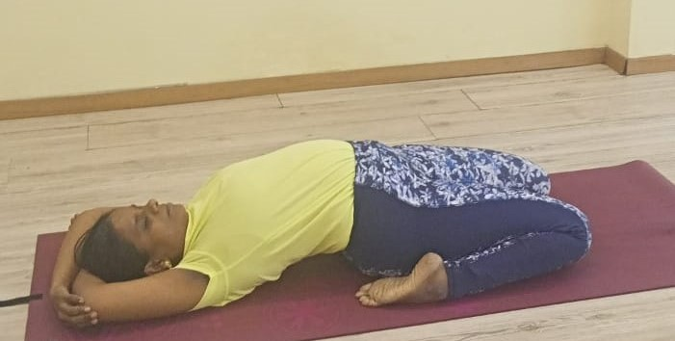

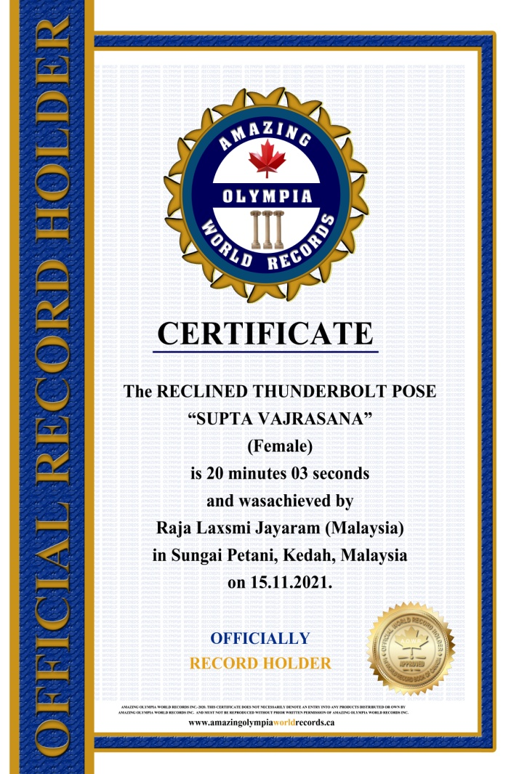
The RECLINED THUNERBOLT POSE

SUPTA VAJARASANA
(Female)

Currently has been measured for 20 minutes & 3 seconds and was achieved by
Ms.Raja Laxsmi Jayaram a Malaysian Citizen in Sungai Petani, Kedah, Malaysia on the date 15 Nov. 2021.

She has been received the title as:
OFFICIAL
“WORLD RECORD HOLDER”

