USTRASANA
“The CAMEL POSE”
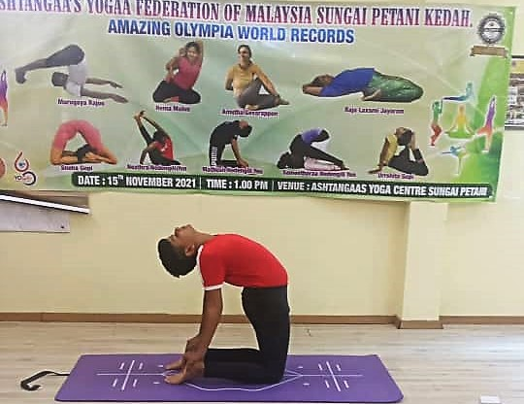

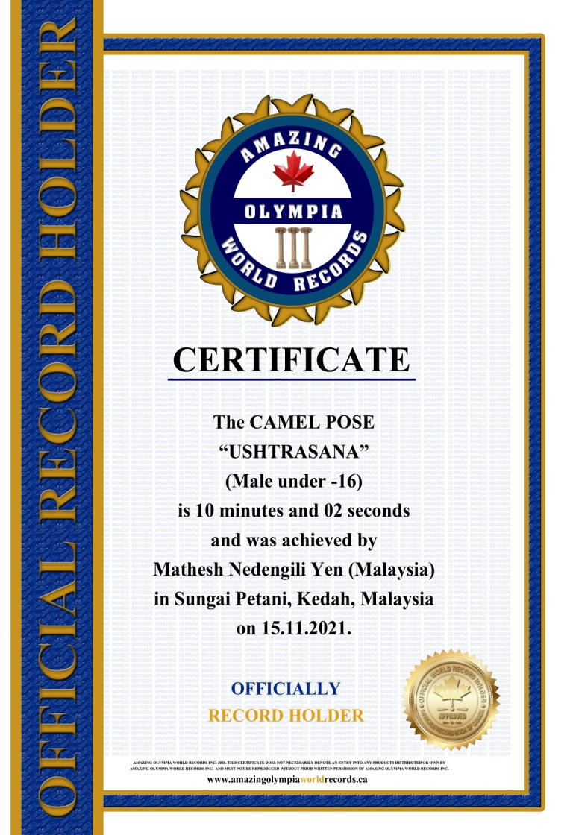
The CAMEL POSE
USTRASANA
(Male Under-16)

Currently has been measured for 10 minutes & 02 seconds and was achieved by
Mr. Mathesh Nedengili Yen a Malaysian Citizen in Sungai Petani, Kedah, Malaysia on the date 15 Nov. 2021.

He has been received the title as:

OFFICIAL
“WORLD RECORD HOLDER”

