HALASANA
“The PLOUGH POSE”
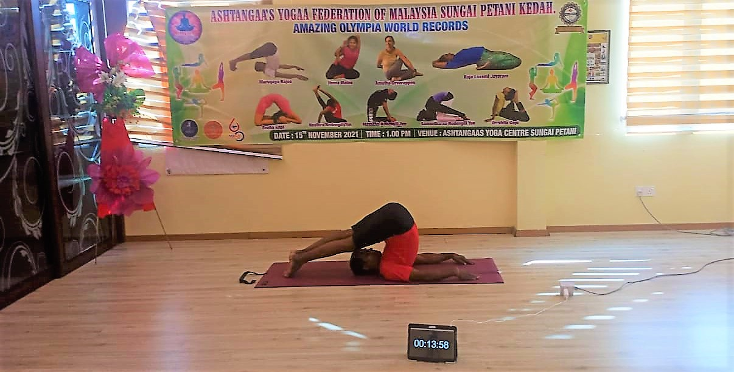

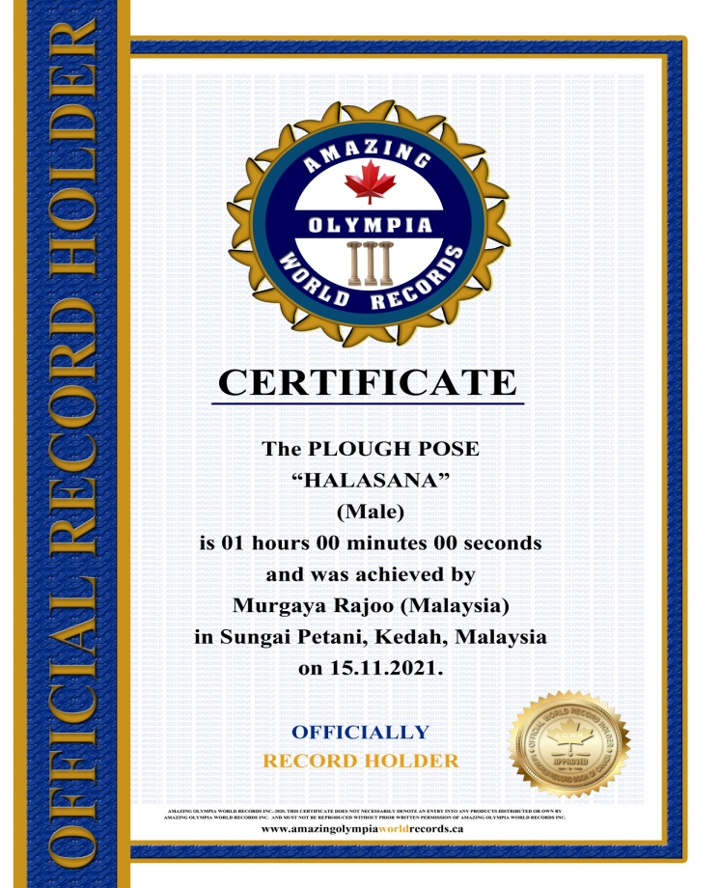
The PLOUGH POSE
HALASANA
(Male)

Currently has been measured for 1 hours 00 minutes & 00 seconds and was achieved by
Mr. Murgaya Ragoo a Malaysian Citizen in Sungai Petani, Kedah, Malaysia on the date 15 Nov. 2021.

He has been received the title as:

OFFICIAL
“WORLD RECORD HOLDER”

