SASANGASANA
“The RABBIT POSE”
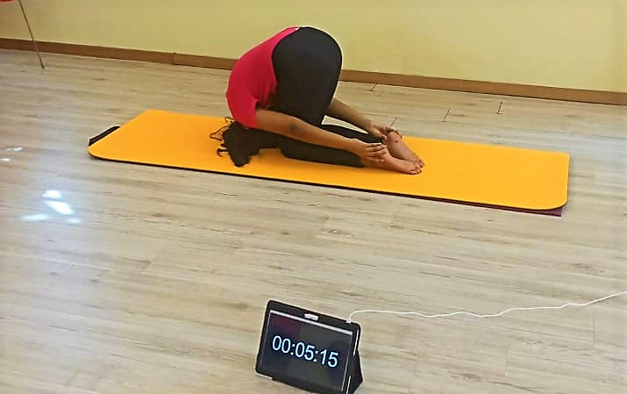

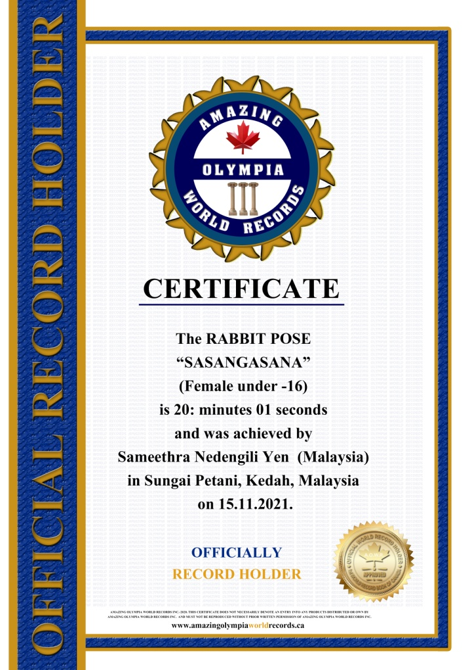
The RABBIT POSE

SASANGASANA
(Female Under -16)

Currently has been measured for 20 minutes & 01 seconds and was achieved by Ms.Sameethra Nedengili a Malaysian Citizen in Sungai Petani, Kedah, Malaysia on the date 15 Nov. 2021.

She has been received the title as:
OFFICIAL
“WORLD RECORD HOLDER”

