PARIVRTTA SURYA YANTRASANA
“The COMPASS POSE”
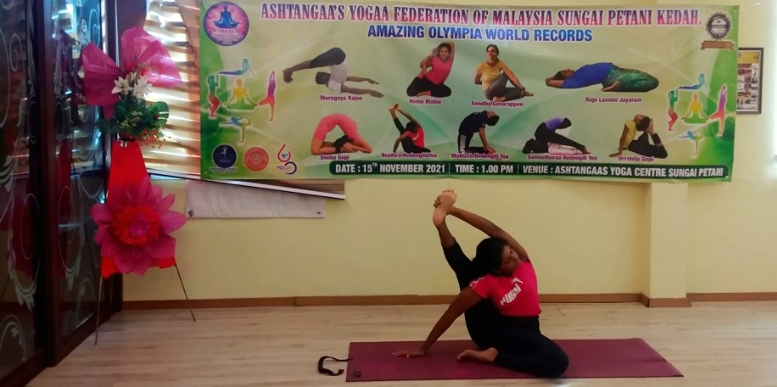
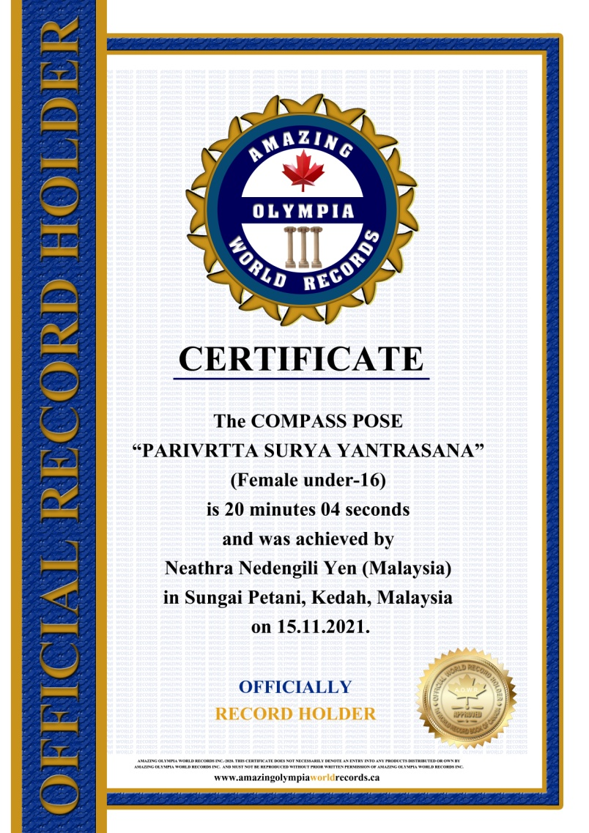
The COMPASS POSE

“PARIVRTTA SURYA YANTRASANA”
(Female Under-16)

Currently has been measured for 20 minutes & 04 seconds and was achieved by
Ms. Neathra Nedengili Yen a Malaysian Citizen in Sungai Petani, Kedah, Malaysia on the date 15 Nov. 2021.

She has been received the title as:
OFFICIAL
“WORLD RECORD HOLDER”

