HANUMAN ASANA
“The GOD MONKEY POSE”


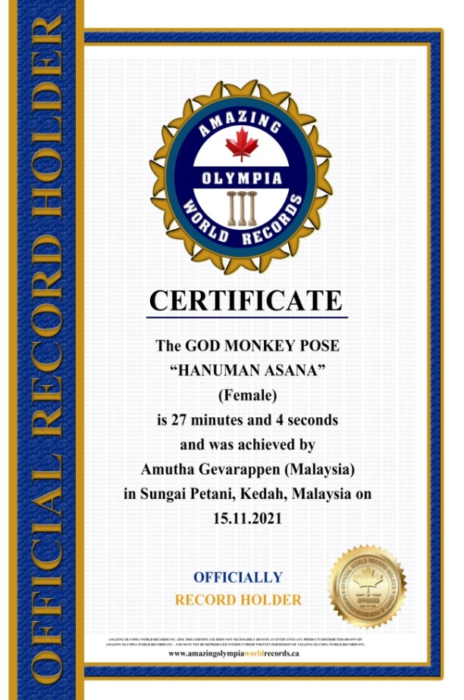
The GOD MONKEY POSE
“HANUMAN ASANA”
(Female)

Currently has been measured for 27 minutes & 04 seconds and was achieved by
Ms.Amutha Gevarappen a Malaysian Citizen in Sungai Petani, Kedah, Malaysia on the date 15 Nov. 2021.

She has been received the title as:
OFFICIAL
“WORLD RECORD HOLDER”

