PURNA BHUJANGASANA
“The COBRA POSE”
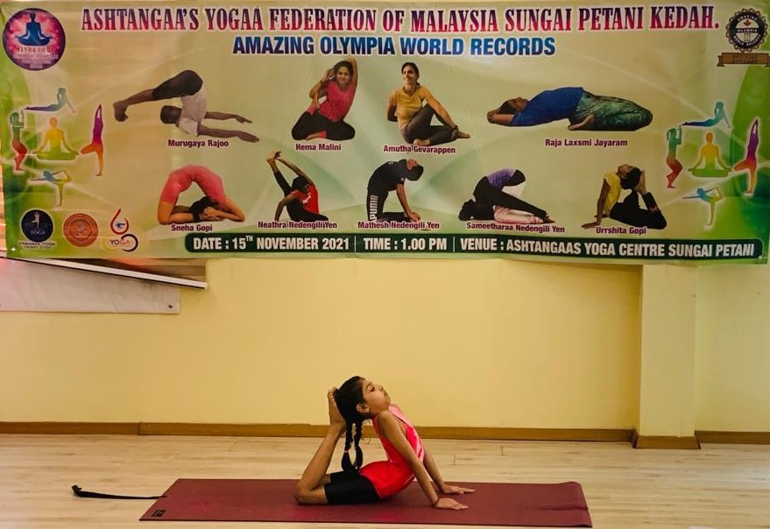

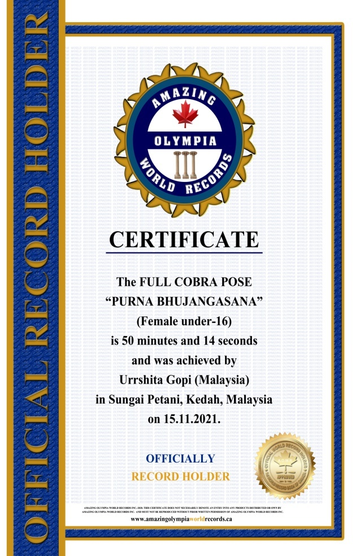
The COBRA POSE

“PURNA BHUJANGASANA”
(Female Under -16)

Currently has been measured for 50 minutes & 14 seconds and was achieved by Ms.Urrshita Gopi a Malaysian Citizen in Sungai Petani, Kedah, Malaysia on the date 15 Nov. 2021.

She has been received the title as:
OFFICIAL
“WORLD RECORD HOLDER”

