PURNA USTRASANA
“The FULL CAMEL POSE”
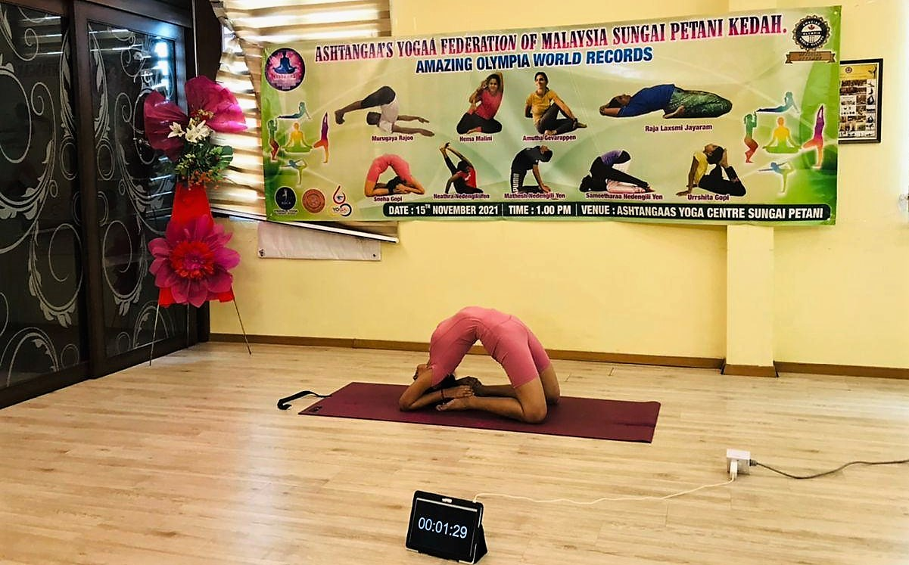

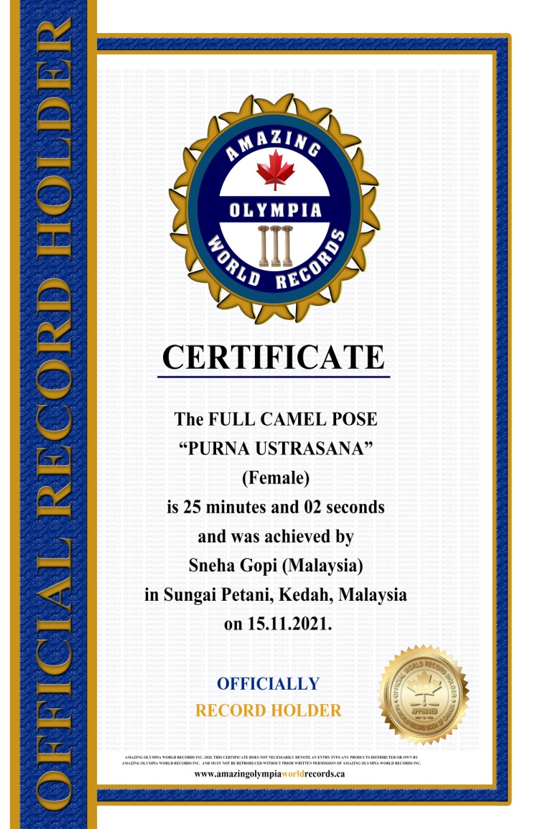
The FULL CAMEL POSE

PURNA USTRASANA
(Female)

Currently has been measured for 25 minutes & 02 seconds and was achieved by
Mr. Sneha Gopi a Malaysian Citizen in Sungai Petani, Kedah, Malaysia on the date 15 Nov. 2021.

He has been received the title as:
OFFICIAL
“WORLD RECORD HOLDER”

